PROMISE & PRACTICE · DEEP DIVE · SOURCE ANALYSIS
The 14th Amendment — A House Divided
Citizenship, Written Into the Constitution
Name: ______________________________ Period: _____ Date: ________________
WHAT I CAN DO TODAY I can read primary sources about The 14th Amendment — A House Divided, weigh who made each one and why, and use evidence to answer historical questions.
Directions. A few phrases remade American law. Read them closely and name what each one does

THE SOURCES
SOURCE · THE 14TH AMENDMENT, SECTION 1 · 1868 — The key clause
“All persons born or naturalized in the United States … are citizens of the United States and of the State wherein they reside. No State shall … deprive any person of life, liberty, or property, without due process of law; nor deny to any person within its jurisdiction the equal protection of the laws.”
— U.S. Constitution, Amendment XIV. Public domain
— U.S. Constitution, Amendment XIV. Public domain.
THE IMAGE · 1865 — “And Not This Man?”
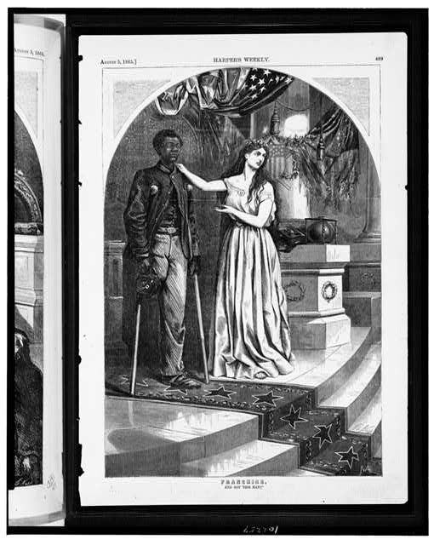
“Franchise — And Not This Man?” — wood engraving by Thomas Nast, Harper's Weekly, 1865, public domain (Library of Congress).

YOUR WORK
QUESTION 1 STEP 1 · THREE PHRASES
In your own words, explain what each phrase means: (a) “born or naturalized … are citizens,” (b) “due process of law,” (c) “equal protection of the laws.”
____________________________________________________________________________________________
____________________________________________________________________________________________
____________________________________________________________________________________________
____________________________________________________________________________________________
QUESTION 2 STEP 2 · OVERTURNING DRED SCOTT
How did the citizenship clause directly reverse the Dred Scott decision of 1857?
☐ A. Dred Scott said Black people couldn't be citizens; the amendment made everyone born here a citizen
☐ B. it freed the enslaved
☐ C. it gave women the vote
☐ D. it had nothing to do with Dred Scott
QUESTION 3 STEP 3 · READ THE IMAGE
Nast draws a Black veteran who lost a leg for the Union. What argument is the image making about why this man deserves citizenship? How does it connect to the amendment?
____________________________________________________________________________________________
____________________________________________________________________________________________
____________________________________________________________________________________________
QUESTION 4 STEP 4 · WHY IT STILL MATTERS
The 14th Amendment's promise went largely unenforced for decades, yet it became the cornerstone of modern civil rights. In three or four sentences, explain how words written in 1868 could matter so much a century later.
____________________________________________________________________________________________
____________________________________________________________________________________________
____________________________________________________________________________________________
____________________________________________________________________________________________
____________________________________________________________________________________________
Promise & Practice · ShadowDog Digital Studios · Unit 2

TEACHER ANSWER KEY — The 14th Amendment — A House Divided

QUESTION 1: Open response.
Look for a response along the lines of: “(a)… (b)… (c)…”
QUESTION 2: Correct — A. Dred Scott said Black people couldn't be citizens; the amendment made everyone born here a citizen
Right. Dred Scott said no Black American could be a citizen. The 14th Amendment made everyone born here a citizen — flatly overturning that ruling.
QUESTION 3: Open response.
Look for a response along the lines of: “The image argues that…, which the 14th Amendment answers by…”
QUESTION 4: Open response.
Look for a response along the lines of: “Even unenforced, the words mattered because…”

